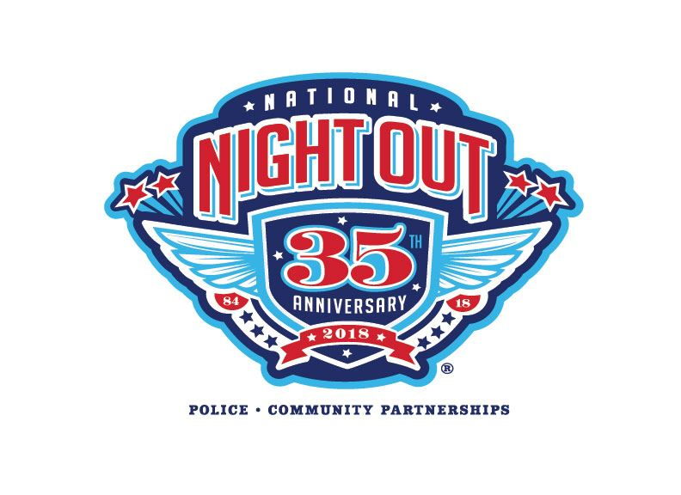
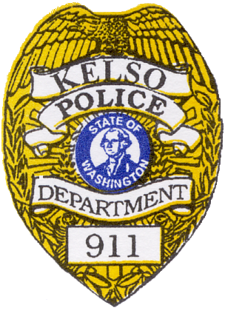
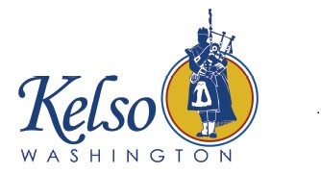

Join Kelso Mayor Nancy Malone,
the Kelso City Council,

Police Chief Andrew Hamilton &
our community partners as
we shut the door
on crime and drugs.

Tuesday, August 7nd, 2018
At Tam O’Shanter Park
1600 Tam O’Shanter Way
Kelso, WA
from 6:00 to 8:30 P.M.

Bring Family, Friends and Neighbors
for a Party in the Park
Free food, prizes for the kids & plenty of fun!

