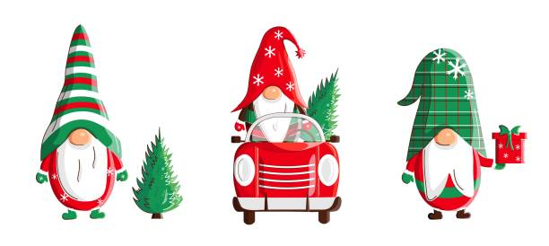

Friday, December 2, 2022
Kelso City Hall – 203 S. Pacific Ave.
6:00 p.m. to 8:00 p.m.

Come join our Tree Lighting Festival to celebrate the beginning of the Christmas season in Kelso. Our theme this year is “Gnome for the Holidays”. We will be lighting the tree at 6:10 pm and Santa will arrive shortly afterwards. Christmas music will be provided throughout the evening: refreshments, games, prizes, a hayride, children’s crafts, children’s face painting, cookie decorating and a special visit from Santa.

Contact Patty at 360-577-3347 or Erica at 360-577-3361

